**DevExpress Report Generation Guide**

**Note** - Ensure that the DevExpress version in your project matches the version installed on your machine. For example, if the provided documentation references version **24.1**, but your system uses **23.2**, update all references from **24.1** to **23.2** throughout the project. (E.g package.json file)

Step 1: Create a New ASP.NET Core MVC Project

- Follow the instructions in the provided documentation to set up the project:

- [Add an End-User Report Designer to an ASP.NET Core MVC Application](https://docs.devexpress.com/XtraReports/401763/web-reporting/asp-net-core-reporting/end-user-report-designer-in-asp-net-applications/quick-start/add-an-end-user-report-designer-to-an-aspnet-core-application)

Step 2: Configure Report Storage

- To enable report saving and management, configure a storage solution for your reports. Use the documentation link below for guidance on storing reports as files:

- [Add a Report Storage (ASP.NET Core) | .NET Reporting Tools | DevExpress Documentation](https://docs.devexpress.com/XtraReports/400211/web-reporting/asp-net-core-reporting/end-user-report-designer-in-asp-net-applications/add-a-report-storage#how-to-store-reports-in-a-file-system)

Step 3: Enable Rich Text Editor

- Enable the Rich Text Editor for enhanced text formatting capabilities in your reports. Refer to the following documentation

- [Enable the Rich Text Editor | .NET Reporting Tools | DevExpress Documentation](https://docs.devexpress.com/XtraReports/401255/web-reporting/asp-net-core-reporting/end-user-report-designer-in-asp-net-applications/add-features-to-the-report-designer/add-a-rich-text-editor)

**Troubleshooting**

- If you follow any error as follow or any other errors then try to use following solution

Uncaught ReferenceError: DevExpress is not defined at dx.richedit.js:67937

This issue typically occurs due to an incorrect order of script file references.

- Solution

change bundle config file

[

//All in one with rich editor

{

"outputFileName": "wwwroot/css/all_in_one.bundle.css",

"inputFiles": [

"node_modules/devextreme-dist/css/dx.light.css",

"node_modules/@devexpress/analytics-core/dist/css/dx-analytics.common.css",

"node_modules/@devexpress/analytics-core/dist/css/dx-analytics.light.css",

"node_modules/@devexpress/analytics-core/dist/css/dx-querybuilder.css",

"node_modules/devexpress-reporting/dist/css/dx-webdocumentviewer.css",

"node_modules/devexpress-reporting/dist/css/dx-reportdesigner.css",

"node_modules/devexpress-richedit/dist/dx.richedit.css"

],

"minify": {

"enabled": false,

"adjustRelativePaths": false

}

},

{

"outputFileName": "wwwroot/js/all_in_one.bundle.js",

"inputFiles": [

"node_modules/jquery/dist/jquery.min.js",

"node_modules/knockout/build/output/knockout-latest.js",

"node_modules/devextreme-dist/js/dx.all.js",

"node_modules/jszip/dist/jszip.min.js",

"node_modules/devexpress-richedit/dist/dx.richedit.min.js",

"node_modules/@devexpress/analytics-core/dist/js/dx-analytics-core.js",

"node_modules/@devexpress/analytics-core/dist/js/dx-querybuilder.js",

"node_modules/devexpress-reporting/dist/js/dx-webdocumentviewer.js",

"node_modules/devexpress-reporting/dist/js/dx-reportdesigner.js"

],

"minify": {

"enabled": false

},

"sourceMap": false

}

]

_Layout file

<!DOCTYPE html>

<html>

<head>

<title>Simple Asp Net Core Reporting Designer</title>

<link rel="stylesheet" href="~/css/all_in_one.bundle.css" />

<link rel="stylesheet" href="~/css/site.css" />

<script src="~/js/all_in_one.bundle.js"></script>

<script src="~/js/site.js" asp-append-version="true"></script>

</head>

<body>

@RenderBody()

</body>

</html>

Index file

@using DevExpress.AspNetCore

@using DevExpressReportMVCDemo.Reports

@(Html.DevExpress().ReportDesigner("reportDesigner")

.Height("1000px")

.Bind(new TestReport()))

**Issue: Missing Report Type Options in the New Report Wizard**

If only "Blank" and "Label" report options are visible in the **End-User Report Wizard** screen, and other report types are not displayed

**Resolution:**

Follow these steps to resolve the issue:

1. Open **Solution Explorer**, right-click on the **Reports** folder, and select **Add** > **New Item**.

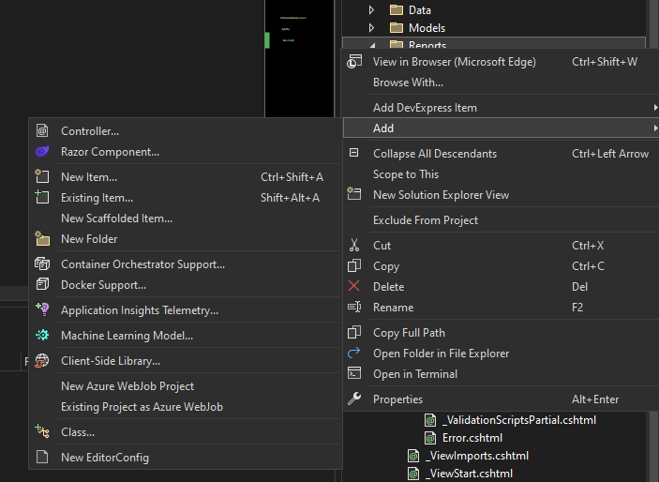

2. Go to the **Reporting** tab and choose the **DevExpress Report** item. Rename the file as desired.

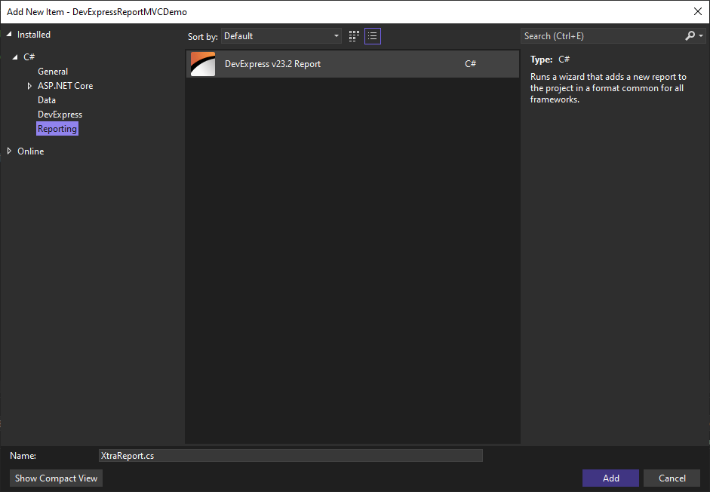

3. In the Report Wizard, select **Table Report** and click **Next**.

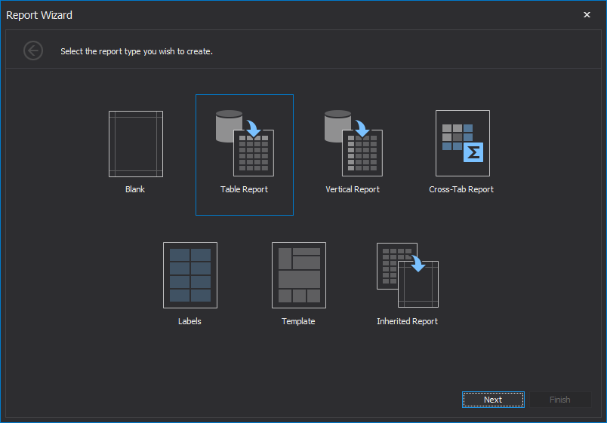

4. Continue selecting **Yes** for the configuration prompts, and proceed by clicking **Next**.

5. Enter a new, unique **connection string name** (different from any previously used).

6. Select the checkbox for **Tables** and click **Finish**.

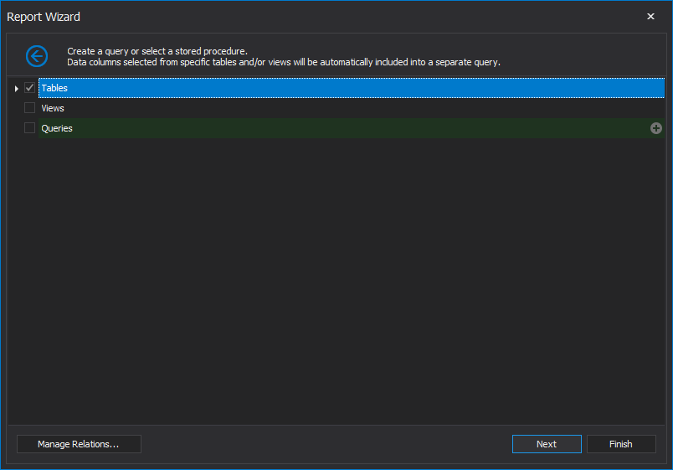

7. Build and run the project to verify that the report is successfully added.

After completing the steps above, you should now see all available report options in the wizard.

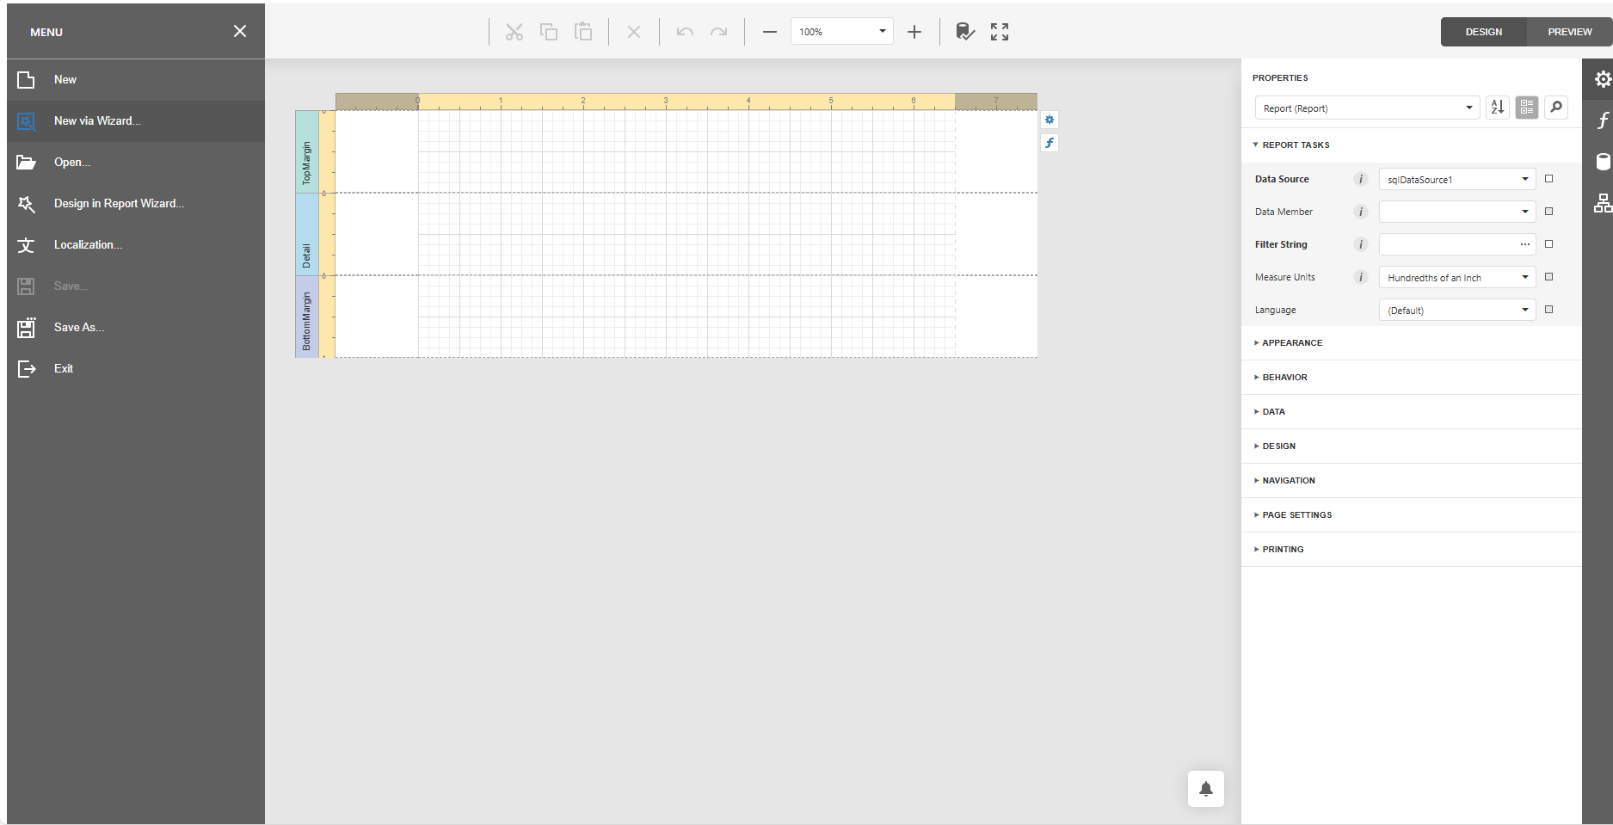

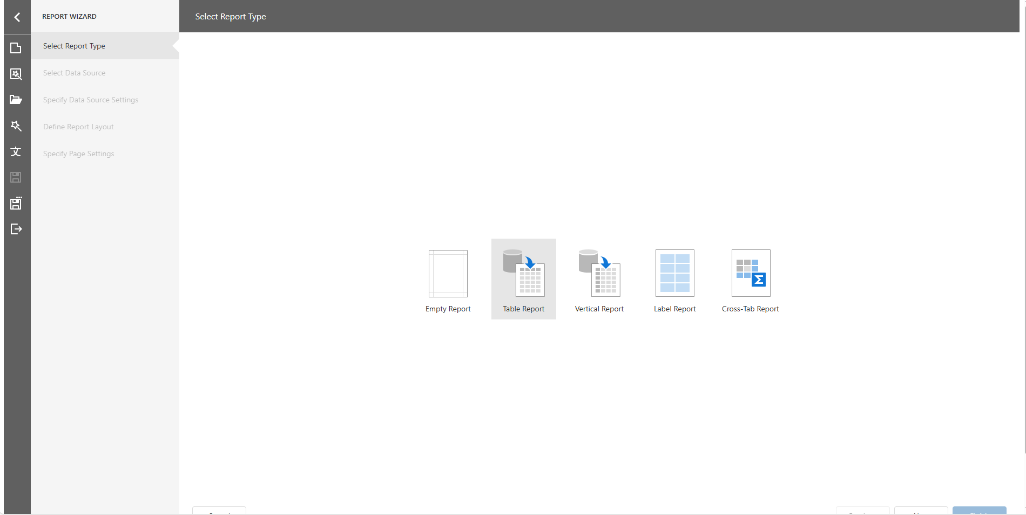

You can proceed to create a new report with a data table, binding the report to your database tables.

Video Ref - <https://app.screencast.com/S4J96oDGbuQbe>